# CS 255 System Design Document Template

*Branden Mccusker*

*6-17-22*

## UML DiagramsImage

## 

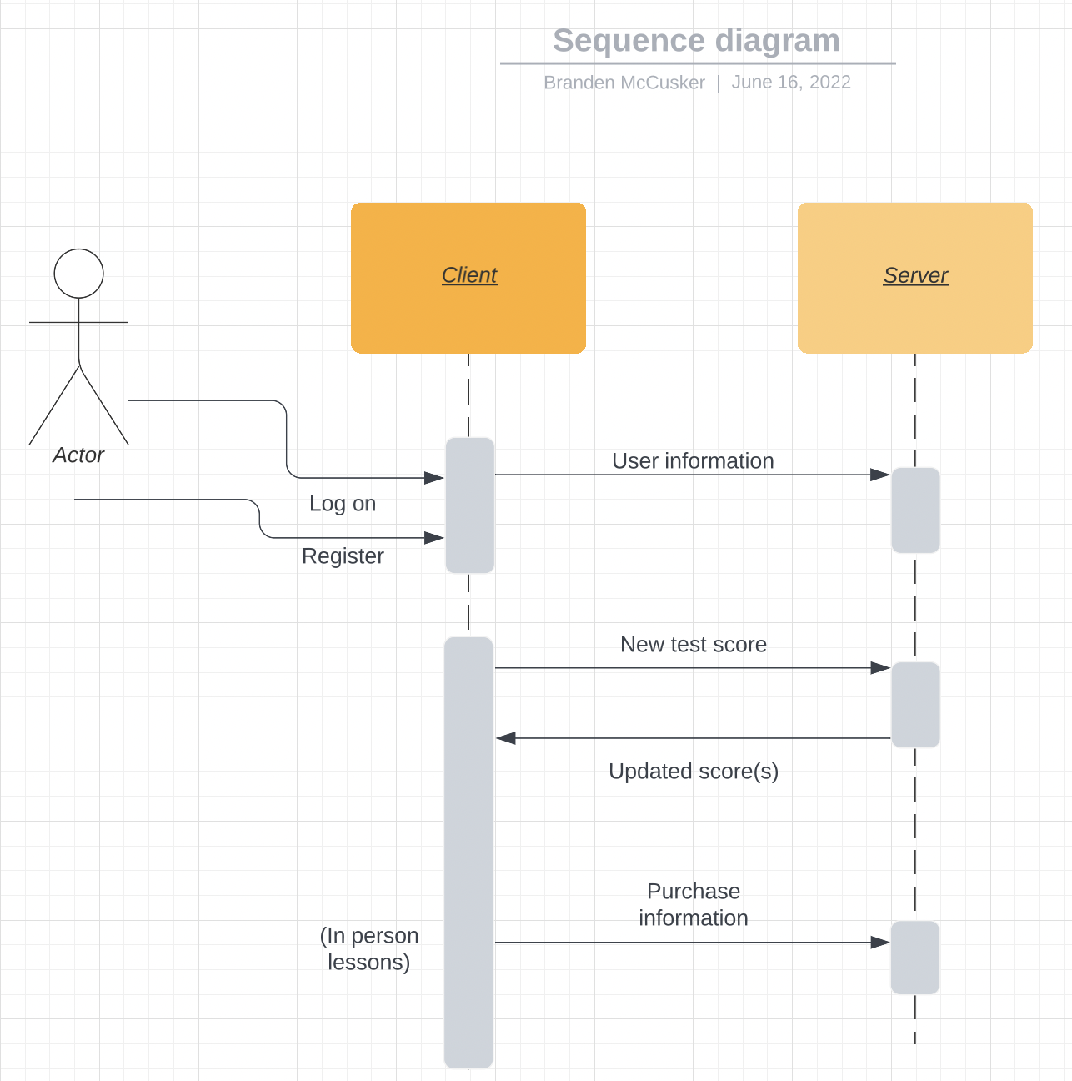

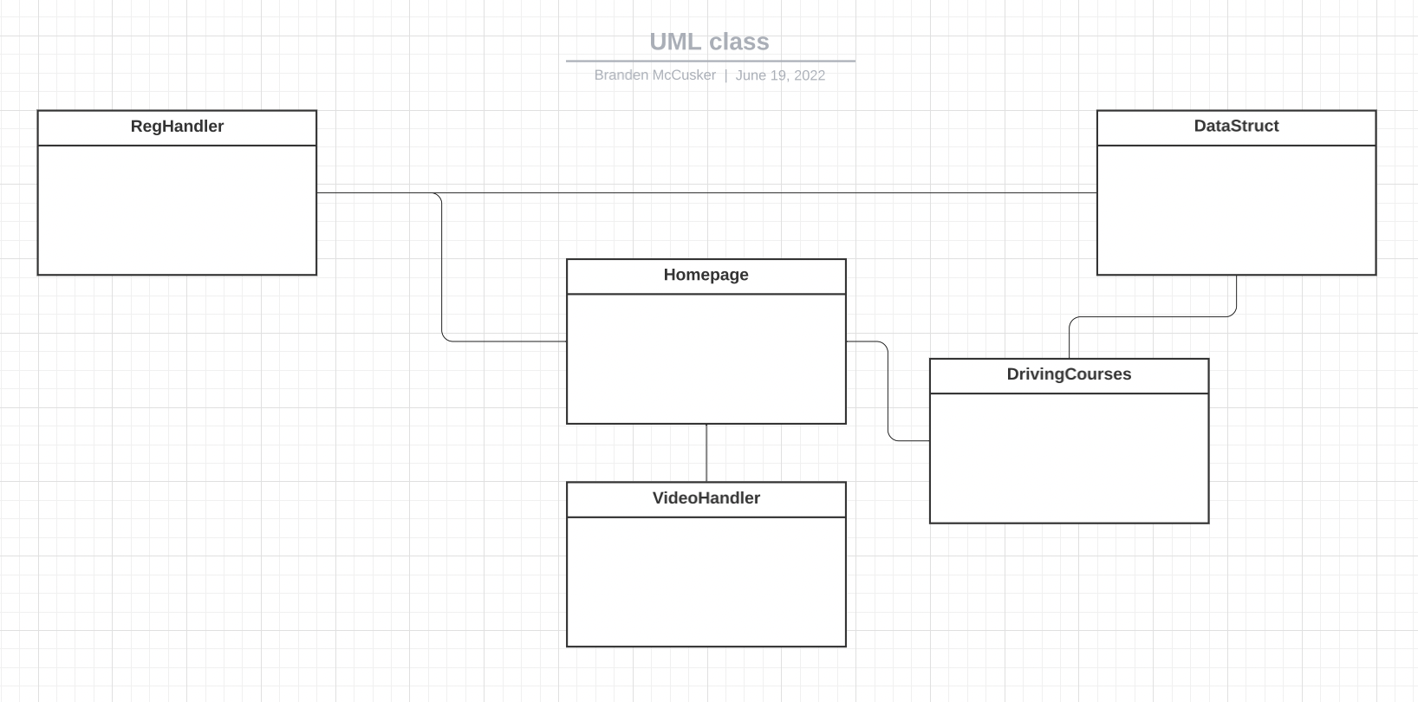

Technical requirements include:

A server to handle the website and data storage (used in DataStruct)

HTML Website

Physical driving training employees

Videos

Tests

Study material